Ryan G. Cooper

Professor Conlan

CS-405 Module 4 Assignment Two

June 2nd, 2024

**Unit Test Code**

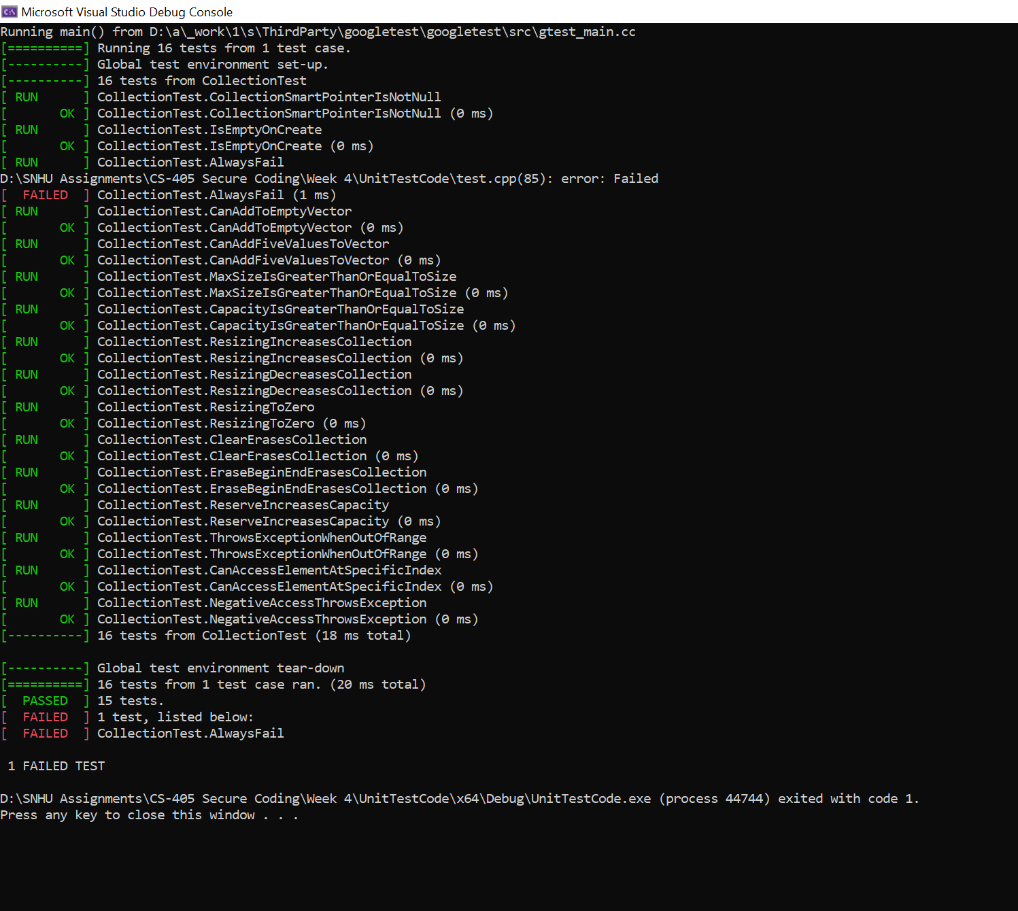

Shown in the above screenshot, all the tests passed except for the AlwaysFail test that should fail. The key issues addressed included ensuring that a collection is correctly initialized and empty upon creation, verifying the addition of elements, and confirming that the resizing operations work. Test cases were made to make sure that the collection's size, capacity, and behavior under different conditions, such as adding multiple elements, clearing the collection, and handling out-of-range access work as expected. Assertions were used throughout the tests so an error message would display, and the program would terminate. Overall, this systematic testing process validates the classes functionality while being robust and reliable.